**Meat Establishment Registration**

Remove “PLUS” Icon

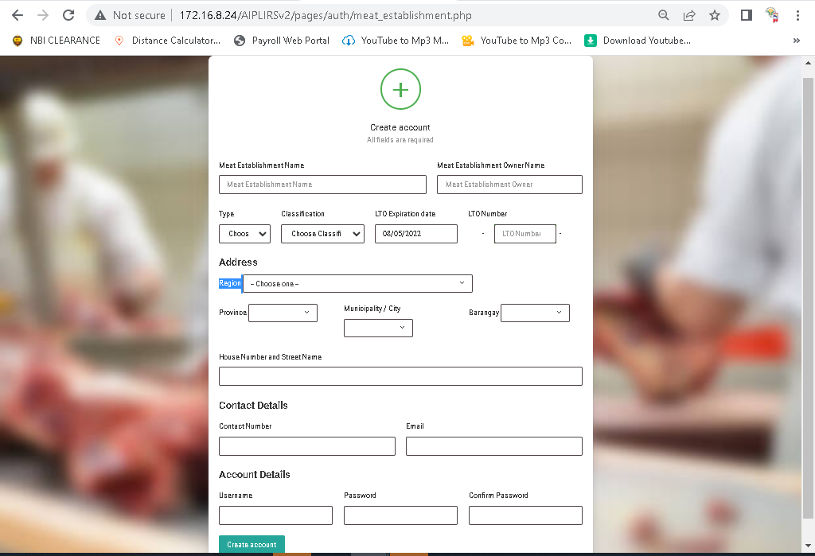

Create account button change to Submit

Make center this button

Move inside the Type, Classification in input

Change SLH to SH

**Meat Inspection Officer Registration**

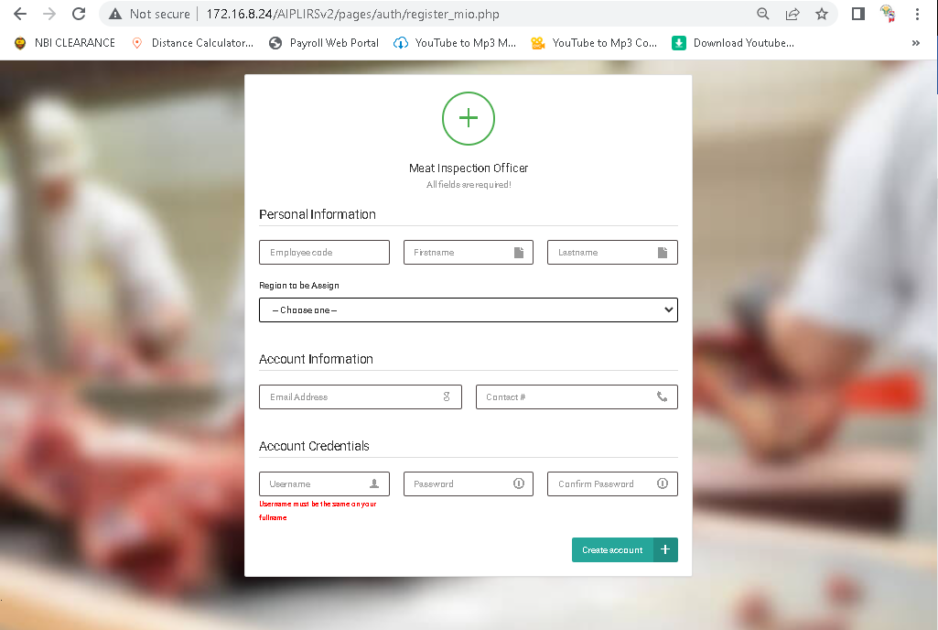

Remove this row and make it an under in “account information” change to “account Details”

Remove “PLUS” Icon

Change to Region Assigned

Limit on number

Employee code to Employee number limit on number

Create account button change to Submit

Make center this button

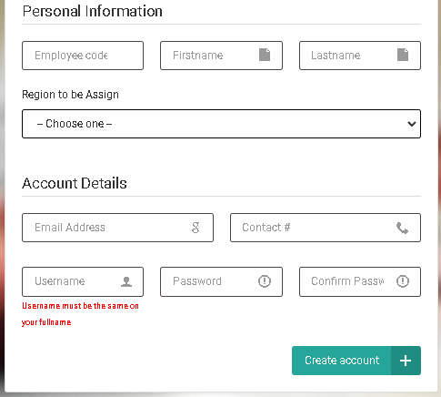

**Plant Operation Standards and Monitoring Section Registration**

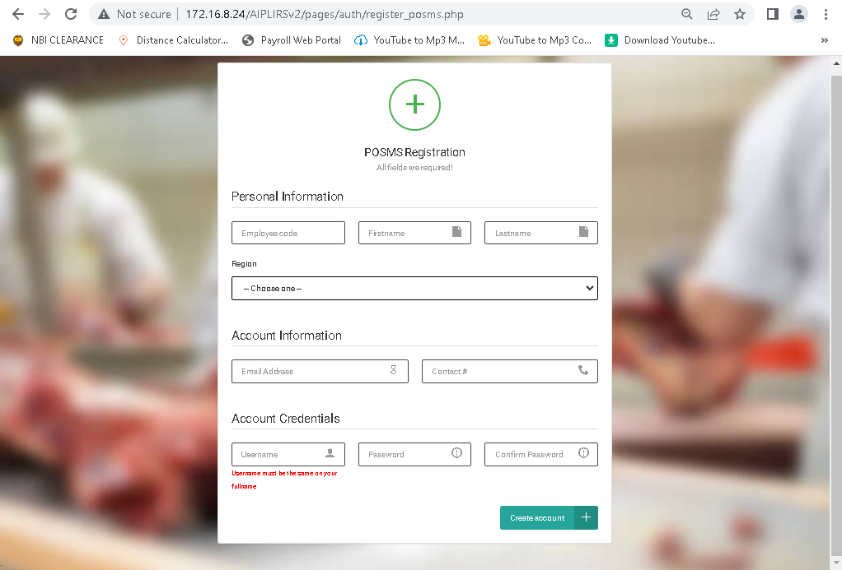

Change to Region Assigned

Employee code to Employee number limit on number

Limit on number

Remove this row and make it an under in “account information” change to “account Details”

Create account button change to Submit

Make center this button